PATCH UPDATE

PREREQUEST:

1.Need to share the Change request to the client.

2.Before starting the patch update activity, need to take the snapshot of the VM’s.

ACTIVITY:

1.Go to Azure Update Manager.

2.And select the VM and click on Pending Updates.

3.In that click on Schedule Updates.

4.Enter the instance details and schedule timing (Max time for updates is 3 hours 55 mins).

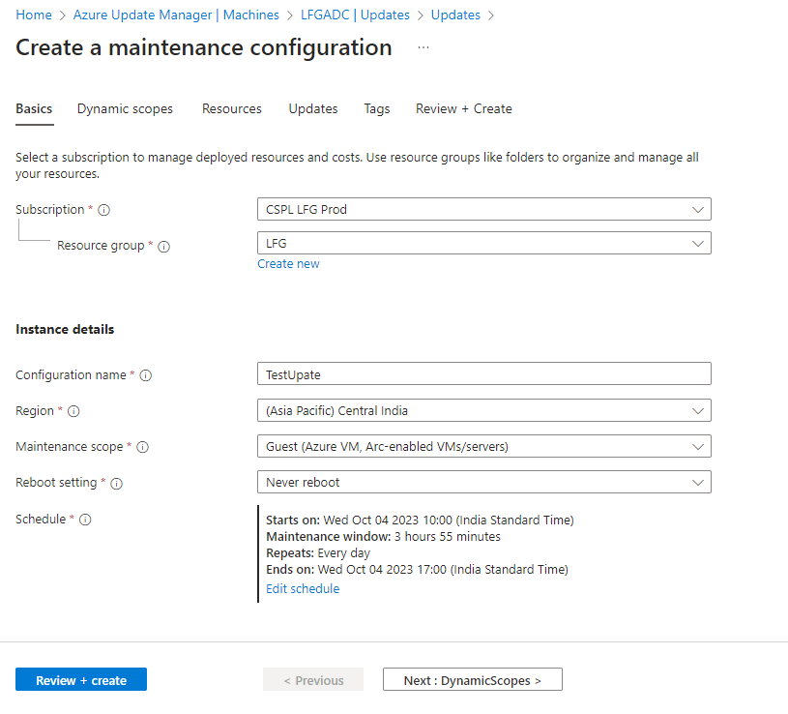

5.In Dynamic Scope don’t need to add any dynamic scopes.

6.In Resources add the VM’s to be updated.

7.In updates, click on include update classification. In that select Critical and security updates.

Note: Need to exclude the SQL version.

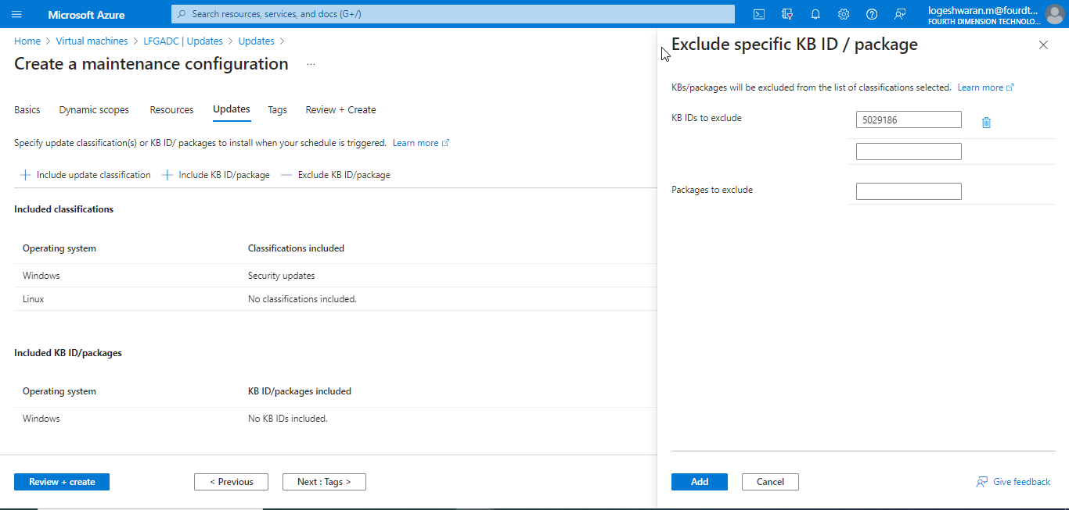

8.In review check and click on Create.

POST UPDATE ACTIVITIES:

1.After Updating the machines. VM’s need to be restarted.

2.After restarting the VM’s. Check whether the Always on in VM is in correct state. Check it in Microsoft SQL Server tool 2019 > Available replicas.

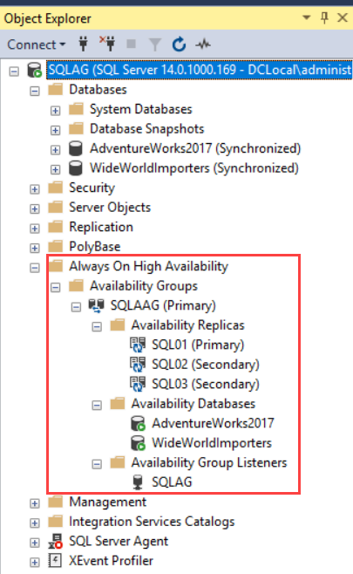

3.If the VM’s Always on, is in changed state. Need to perform Failover or VM need to be restarted.

NEW VM PATCH UPDATE:

1.If we are updating the new VM. Need to enable this option (**Periodic assessment**) in VM.

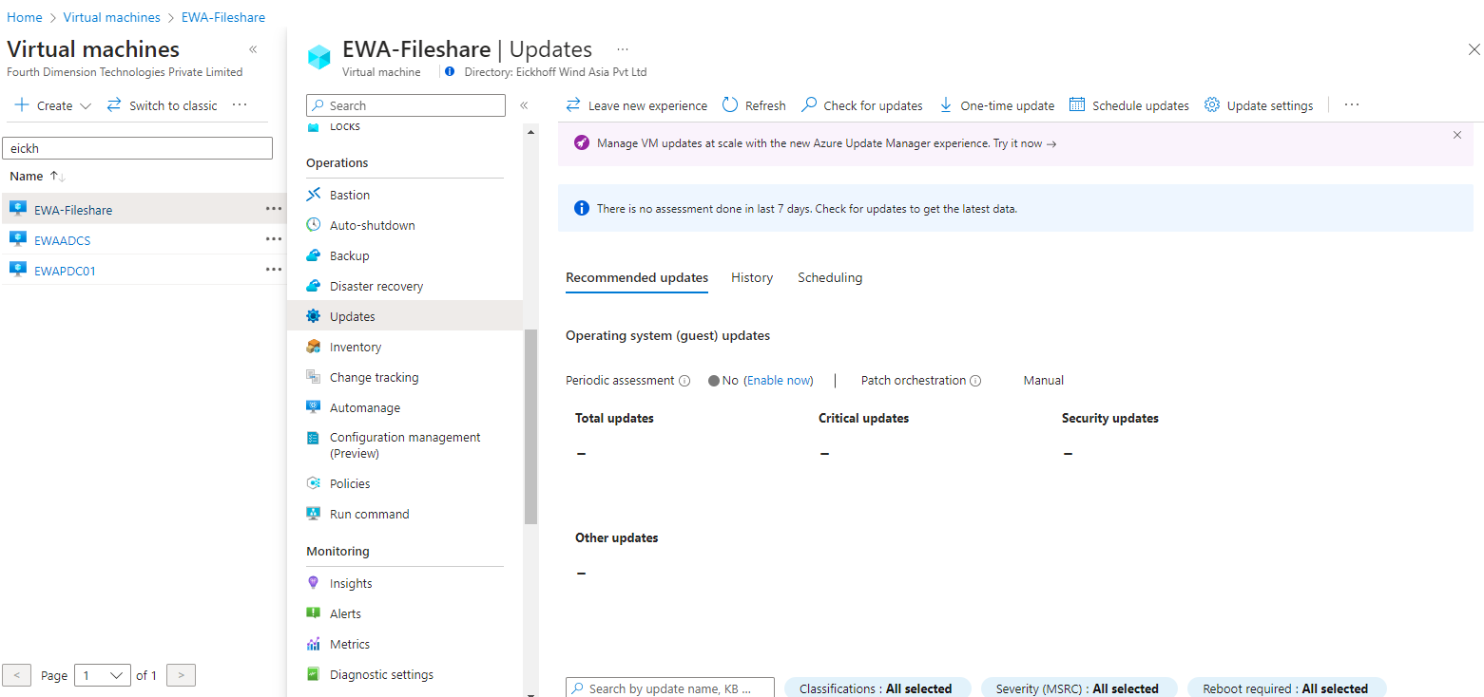

2.In update settings default settings has been enabled (Windows Automatic updates), we need to change the settings to (Customer Managed Schedules).

ERRORS:

1.If we receive any Fatal error during Patch update, incase we can’t start the VM. Need to convert the snapshot into Disk.